**Relational Modelling Quiz II**

**Question 1**

This is the symbol for a relationship in Crow's feet notation.



What would be the equivalent in UML (or Chen's) notation?

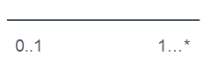

**Question 2**

We have a data table about books that looks like this:

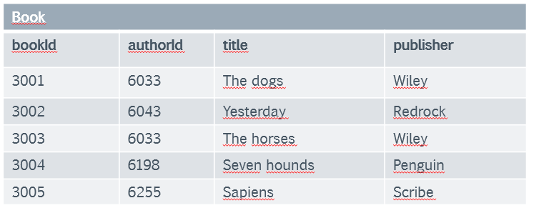

What do you think is its most likely representation in UML?

**Question 3**

We are modelling the following relationship:

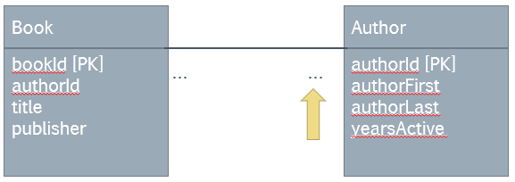

At this point, we are determining the cardinalities (one-to-one, one-to-many...) including whether a related entry must exist in the other relation.

How do we test for the cardinality the yellow arrow points at?

* We ask ourselves, 'for every book, how many related authors can exist in the Author table? Must there be at least one author for every book?'

**Question 4**

We have the following two relations:

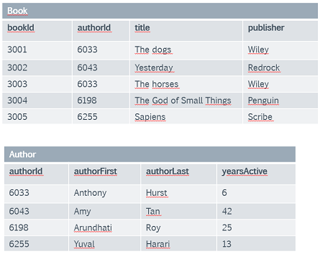

We are assuming that a book can (and must) have one author. How would you model the relationship between these two relations, including the foreign key(s)?

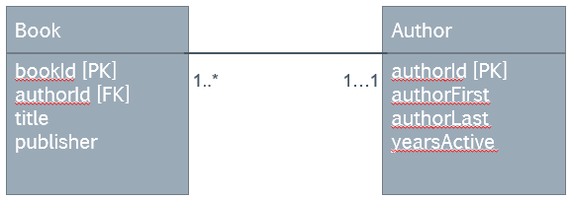

**Question 5**

We have the following relationship cardinalities between two relations:

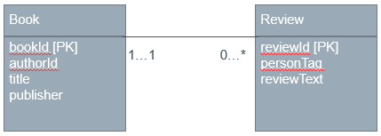

Note the diagram is incomplete - the foreign key is not shown. According to the relationship shown, how would you fix this?

* You would add bookId to the Review table as a foreign key.

**Question 6**

The Book table has so far been modelled under the assumption that the publisher is just mentioned by name, and the database does not record any further details of the publisher, as shown here:

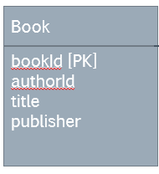

We have just revised this decision, and are updating the database to include the following information about the publisher:

* An ID attribute to identify the publisher;
* the name of the publishing company;
* the country where the publisher operates;
* the phone number to contact the publisher.

Choose the best design solution for this scenario.

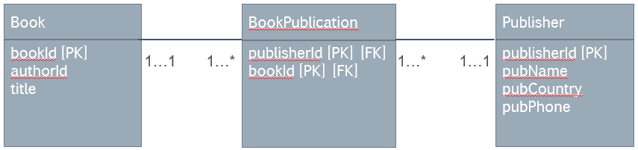

**Question 7**

We are now working with the database of a real estate agent. One of the important concepts are viewings: A potential client having a look at a property they are interested in. The Viewing relation now looks like this:

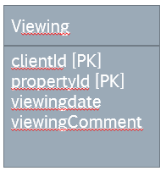

There are also relations called Client and Property, but they are omitted for clarity.

Which of the following is NOT a potential limitation of the Viewing table?

* The foreign keys to the Client and Property tables are not shown. We don't know if the relationships exist.

**Question 8**

The Viewing relation now has added information about who of the staff has conducted the viewing.

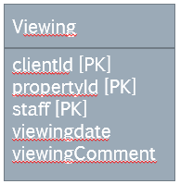

The related tables Staff, Client and Property have been omitted from the picture (they are not relevant to the question).

Which of the following is TRUE about this table?

* The same client can view the same property several times if each viewing is organised by a different staff.